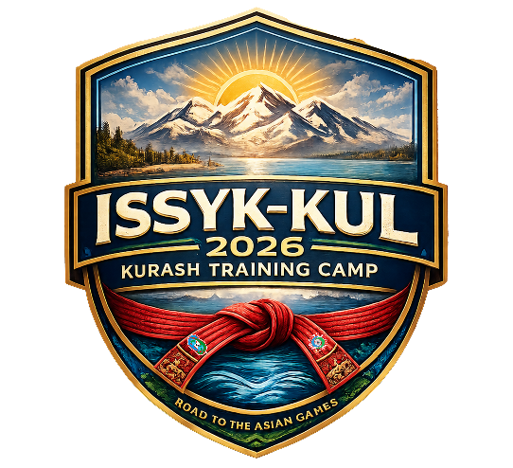

APPLICATION FORM
for official accreditation and visa at the ISSYK-KUL 2026 International Kurash Training Camp
26 July – 10 August 2026 · Issyk-Kul, Kyrgyz Republic

PLEASE FILL IN AND SEND THIS APPLICATION AND PASSPORT COPY BEFORE 15 July 2026 (visa 10 July)
TO : kurash.kkf@gmail.com, eralievmika@gmail.com

Federation information
Name of Federation
Name of Federation President
Contact telephone with codes
Email
Address

Status | Given Name | Surname | Date of Birth  (d/m/y) | Citizenship | Passport No. | Date of issue  (d/m/y) | Expiry date  (d/m/y)
Team Leader
Team Official
Coach
Coach
Coach
Coach
Referee
Male -60 kg
Male -66 kg
Male -73 kg
Male -81kg
Male -90kg
Male -100 kg
Male -120 kg
Male +120 kg
Female -48 kg
Female -52 kg
Female -57 kg
Female -63 kg
Female -70 kg
Female -78 kg
Female -87 kg
Female +87 kg

For countries requiring visas, please kindly attach participants’ passport copies and color passport-size photographs with a white background in separate folders and submit them in archived (ZIP/RAR) format.

